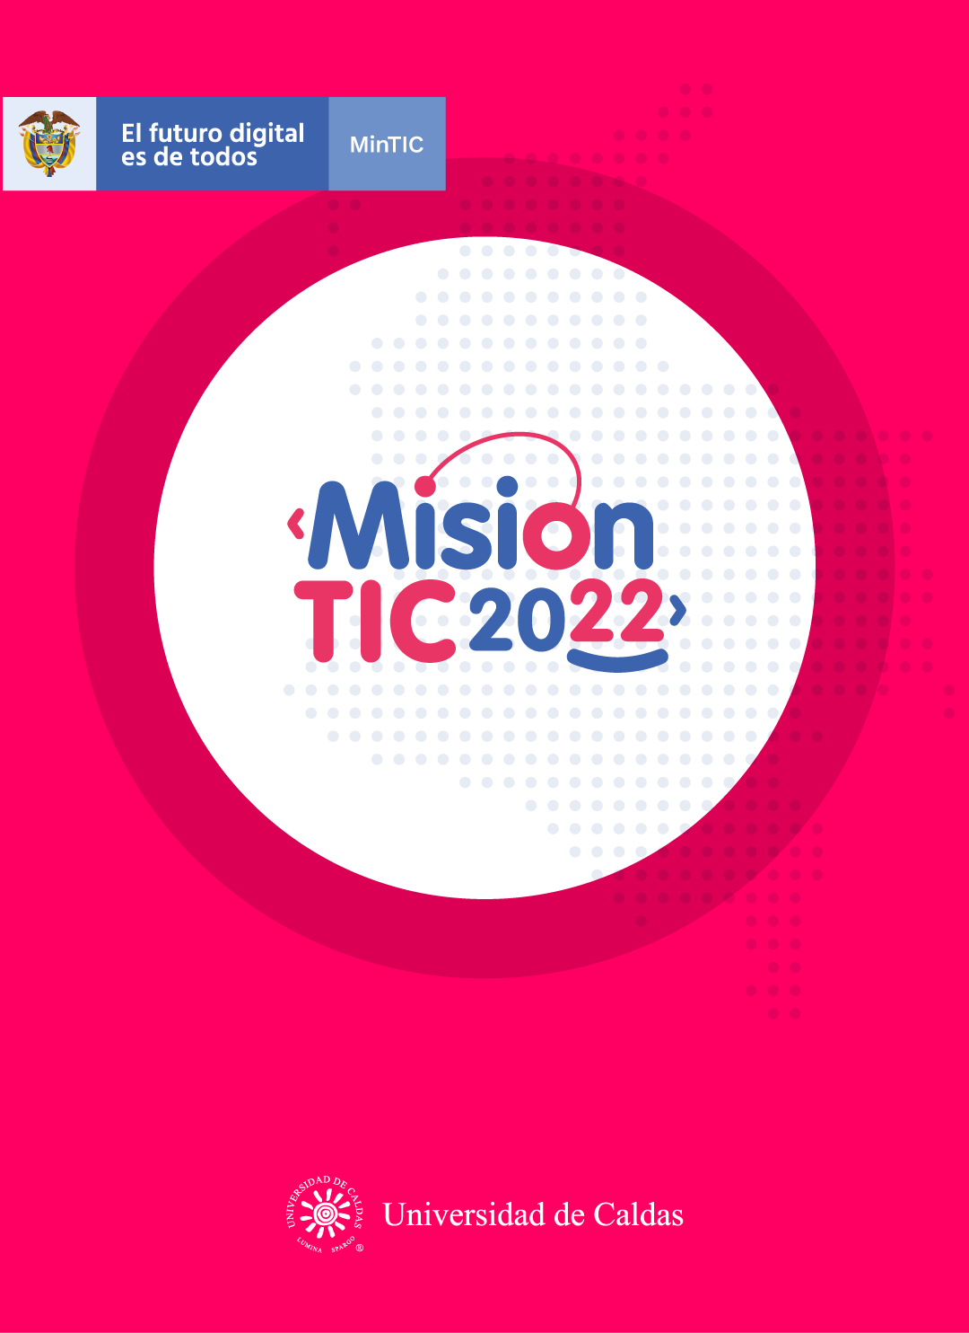

**PERSISTENT STORAGE**

**Worksheet 2.1**

**Write down the possible translation for every word, according to the guessing game.**

**Vocabulary**

* [Storage](https://searchstorage.techtarget.com/definition/storage): Almacenamiento/ store: almacenar
* Power:Energia or energy
* Shut off: turn off / Apagar
* [hard disk drives](https://searchstorage.techtarget.com/definition/hard-disk-drive):Disco duro / unidad disco duro
* Requirement: Requisito / requerimiento
* Shared:compartido / share: compartir
* Cloud: Nube
* Assumed:Asumir / supuesto
* Solid-state: Unidad de estado solido
* Rely on: Depend on / depender de / confiar en
* Loss: perdida/ lose:perder/lost:perdido

**Worksheet 2.2**

**After practicing with your teacher and classmates the meaning of the words, write down a definition or concept for each word. Use the anagram activity to help yourself.**

* **SHUT OFF: If a machine or system shuts off,or if someone or something it off,it stops perating.** IF A MACHINE OR SYSTEM SHUTS OFF, OR IF SOMEONE OR SOMETHING SHUTS IT OFF, IT STOPS OPERATING.
* **CLOUD**:A computer network where files and programs can be stored, especially the internet A COMPUTER NETWORK HE INTERNET.
* **HARD DISK DRIVE**:An electromechanical storage at store and retrieves digital data using magnetic storageN ELECTRO-MECHANICAL STORAGE DEVICE THAT STORES AND RETRIEVES DIGITAL DATA USING MAGNETIC STORAGE.
* **STORAGE**:The action or method of storing something for future use THE ACTION OR METHOD OF STORING SOMETHING FOR FUTURE USE.
* **RELY ON**:To trust someone or something or to expect him,her, or it to behave in a particular wayTO TRUST SOMEONE OR SOMETHING OR TO EXPECT HIM, HER, OR IT TO BEHAVE IN A PARTICULAR WAY.

**POWER**:supply (a device) with mechanical or electrical energy SUPPLY (A DEVICE) WITH MECHANICAL OR ELECTRICAL ENERGY.

**SOLID-STATE**:Refers to a electronic components devices and systems based enterelly on the semiconductor REFERS

**REQUIREMENT**:something you must do, or something you needMETHING THAT YOU MUST DO, OR SOMETHINGTO ELECTRONIC COMPONENTS, SEMICONDUCTOR.

* **ASSUMED**: To accept something to be true without question or proof ACCEPT SOMETHING TO BE TRUE WITHOUT QUESTION OR PROOF.
* **SHARED**:Owned,divided,felt or experienced by more than one person OWNED, DIVIDED, FELT, OR EXPERIENCED BY MORE THAN ONE PERSON.
* **LOSS**:The fact that you no longer have something or have less of something THE FACT THAT YOU NO LONGER HAVE SOMETHING OR HAVE LESS OF SOMETHING.

**Worksheet 2.3**

**Watch the video about the reading strategy Author’s Purpose with PIE and work on the next activities.**

**1. What does PIE stand for? Persuade,inform,entertain,books**

**2. Author’s purpose helps to understanding a topic.**

**3. Give some examples of PIE**

**P – reviews,advertisement,billboards**

**I –documentary or non-fiction tv ,recipes or how-to books,essays,articles,biographies,newspaper,magazines and non fiction books**

**E – comics,magazines,riddles,stories,jokes,magical stores,fiction books,mysteries,comics,fantasy and magical books**

**4. Share your answers with the group.**

**Note: You’ll have 6 minutes to watch the video and share the answers on the chat.**

**Note 2: Remember that you can activate subtitles and slow down the video.**

**Worksheet 2.4**

* **Read the text and state the author’s purpose following the PIE concepts.**
* **Share your answer on the chat**

**Persistent Storage**

Persistent [**storage**](https://searchstorage.techtarget.com/definition/storage) is any data storage device that retains data after **power** to that device is **shut off**. It is also sometimes referred to as [non-volatile storage](https://searchstorage.techtarget.com/definition/nonvolatile-storage). Magnetic media, such as [**hard disk** **drives**](https://searchstorage.techtarget.com/definition/hard-disk-drive) and [tape](https://searchdatabackup.techtarget.com/definition/magnetic-tape) are common types of persistent storage, as are the various forms of [optical media](https://searchstorage.techtarget.com/definition/optical-media) such as DVD.

“Storage persistence” is usually the very basic **requirement** of any storage system, whether it refers to a single drive, a **shared** networked storage system or a [**cloud** storage](https://searchstorage.techtarget.com/definition/cloud-storage) service. “Persistence” is **assumed**, so it is not very common that it is mentioned as a technical specification for storage devices and systems.

**Persistent solid-state storage**

[**Solid-state** drives](https://searchstorage.techtarget.com/definition/SSD-solid-state-drive) are also examples of persistent storage, but they are different from the other forms of persistent media in that they do not have any moving parts, either internally or with the drives required to access the media.

Some types of solid state storage, for example the chips used for [RAM](https://searchstorage.techtarget.com/definition/RAM-random-access-memory) and [cache](https://searchstorage.techtarget.com/definition/cache-memory) systems, are typically non-persistent (Volatile) storage devices which means that the data they hold is erased when continuous power stops. However, certain types such as [non-volatile RAM](https://searchstorage.techtarget.com/definition/nonvolatile-memory) and flash-based RAM are persistent; typically, they **rely on** battery power when the main source of electricity is disconnected. Because RAM holds active work, which was not saved to a disk drive or solid-state drive, RAM persistence may prevent data **loss** in the event of a crash or reboot.

Of course, volatile or non-persistent storage resources have one advantage: since they lose all their data when power is disconnected, they generally present less of a security risk compared to persistent storage equipment.

**Worksheet 2.5**

**Answer the next questions based on the text.**

1. Does persistent storage erase data after powering off the device? No they don´t erase data because they aren’t volatile storage
2. What could be two examples of persistent storage?

Dvd,cd,hdd

1. Do solid-state drives have moving parts?

No it doesn’t has moving parts it has a different way to access to data

1. What could prevent RAM persistence? RAM persistence may prevent data **loss** in the event of a crash or reboot.
2. What’s one of the advantages of the volatile storages, according to the text?

generally present less of a security risk compared to persistent storage equipment.

**Worksheet 2.6**

**Answer the following questions!**

1. Entiendo qué es Persistent Storage.

Yes **😃** Maybe **😐** No **😟**

1. Puedo describir qué es Persistent Storage a un compañero.

Yes **😃** Maybe **😐** No **😟**

1. Entiendo en qué consiste la estrategia State Author’s Purpose.

Yes **😃** Maybe **😐** No **😟**

1. Puedo establecer el propósito del autor en un texto.

Yes **😃** Maybe **😐** No **😟**